COST ANALYSIS
Introduction

When an entrepreneur decides to produce a commodity, he has to pay the price for inputs which he uses in production. When he employs labour, he pays wages to them and pays money when buys raw materials, fuel and power, rent for the factory building and so on. All these are included in cost of production. The kind of cost concept used in a particular situation depends on cost of production. The kind of cost concept used in a particular situation depends upon the business decision that the management makes. An accountant will take into account only the payments and charges made by the
manager to the suppliers of various productive inputs, but the managerial economist views the cost in some what different form. The cost estimates made by conventional, financial accounting are not appropriate for all managerial uses, Further different problems call for different kinds of costs, therefore it is necessary to have a complete understanding of different cost concepts for clear business thinking

The term cost simply means cost of production. It is the expenses incurred in the production of goods. It is the sum of all money-expenses incurred by a firm in order to produce a commodity. Thus it includes all expenses from the time the raw material are bought till the finished products reach the wholesaler.
A managerial economist must have a proper understanding of the different cost concept which is essential for clear business thinking. The cost concept which is relevant to business operation and decision can be grouped on the basis of their propose under two overlapping categories:

- Concept used for accounting purpose
- Concept used in economics analysis of the business
4.2 Types of Cost (or Cost Concepts)

According to Marshall, the real cost of production includes the “real cost of efforts of various Qualities” and “real cost of waiting” It is also known as “alternative sacrificed cost, or “transfer cost”. Opportunity cost of a commodity
is the alternative sacrificed in order of order to order to obtain it. Cost concepts differ because of differences in view point. Different combinations of cost ingredients are important for various kinds of management problems. Disparities occur form deletions, from additions from recombination which do not appear anywhere in the accounting records.
There are several types of costs( or cost concepts).Following are the important items:-
(a) Actual cost and opportunity costs
(b) Past and future costs
(c) Short run and long run costs
(d) Variable or Prime cost and fixed costs or supplementary costs
(e) Incremental costs and sunk costs
(f) Traceable and Non-Traceable costs
(g) Explicit and Implicit costs
(h) Controllable and Non-Controllable Costs
(i) Private, External and social costs
(j) Total. Average and Marginal Costs
(a) Actual Cost and Opportunity Cost

Actual costs are those that involve financial expenditure incurred for acquiring inputs for producing a commodity. These expenditures are recorded in the books of accounts of the firm. The expenditures are wages, payment made for the purchase made for the purchase of raw materials machinery etc. These costs are called actual costs or outlay costs or real costs. The real cost of production has been interpreted
in different forms. According to Adam Smith, “Pains and sacrifices of labour are real cost of production” Opportunity cost is not the actual expenditure but it is the revenue earned by employing that good or service in some other alternative uses. Opportunity cost is the cost of producing any commodity in the next best alternative cost. For example the inputs which are used to manufacture a car may also be used in the productions of military equipment. A farmer who is producing paddy can also produce sugar cane with the same factors. Therefore, the opportunity cost of one quintal of paddy is the amount of sugarcane given up. Main points of opportunity cost are:
- The opportunity cost of any commodity is only the next best alternative
Forgone.
- The next best alternative commodity that could be produced with the
same value of the factors, which are more or less the same.
3. It helps in determining relative prices of factor inputs at different places.
4. It helps in determining the remuneration to services.
5. It helps the manager to decide what he should produce in the factory.

(b) Past and Future Costs
Past costs are actual costs incurred in the past. These costs are mentioned in the financial accounts. Future costs are those costs which are to be incurred in the near future. This is only a forecast. Future costs matter for managerial decisions because, the management can evaluate the desirability of that expenditure, since the past costs are costs that have already been incurred, and there is no scope for managerial decision. If the management finds out that the past costs are excessive, it cannot do anything to rectify it now. In the case of future costs, if the management considers them very high , it can either reduce them or postpone the use of them.
(c) Short Run and Long Run Costs
Shorts run costs are those associated with variation in the utilization of fixed plan or other facilities, whereas long run costs encompass changes in the size and kind of plant. Short run cost is relevant when a firm has to decide whether or not to produce more or less with the given plant and equipments. If the firm decides to expand the capacity of the plant, it must examine the long run cost. Long run cost is useful in making investment decisions.
(d) Prime or Variable Costs and Supplementary or Fixed Costs
Prime costs are variable or direct costs. Normally, they include the money cost of the raw material used in making a commodity, the wages of the labour directly spent on it and the extra wear and tear of the machine that makes it. Suppose a carpenter has been asked to charge for a chair, he would first think of the wood and cane that he used and the number of days he spent in making it. This is the prime cost. It is clear that prime cost of a commodity differs with the quantity produced. When more chairs are made, more money will have to be spent on carpenter’s wages as well as on wood. When production is stopped, the prime costs disappear. Prime costs therefore are also called the Variable Costs.

(d) Supplementary or Fixed Costs

The carpenter will not only charge for the chair but also for the wood and his wage. In addition to the above he will think of including a portion of rent in the cost that he is paying and also interest on the capital invested, the municipal taxes, etc. A big company will further have to include a portion of the salaries of the manager, the peons, the cost of advertisement and salesmanship, etc. These costs must also be covered. They are called supplementary costs on costs or over head charges or fixed costs. The fixed costs do not change with the volume of production. Irrespective of quantity of goods produced, big or small, the charges on account of rent, taxes, interest salaries, etc will be included. Even if the orders cease to flow in and the factory is closed, these costs will continue. They are fixed costs. Generally, the distinction between the variable and fixed costs applies only to the short period, because nothing can really remain fixed in the long run. In the long the strength and the salary bill of the staff may change, the amount of capital invested may be different, hence the amount of interest would vary. Thus, all costs, which ware regarded as fixed in the short run, may vary in the long run. Thus in the long run, all costs are variable.
(e) Incremental Costs and Sunk Costs

Incremental costs are the added costs of a change in the level of production or the nature of activity. It may be adding a new product or changing distribution channel, or adding new machinery, etc. It appears to be similar to marginal cost, but it is not managerial cost. Marginal cost refers to the cost on added unit of output. Sunk costs are costs which cannot be altered in any way. Sunk costs are costs which have already been uncured. For example, cost incurred in constructing a factory. When the factory building is constructed costs have already been incurred. The building has to be used for which originally envisaged. It cannot be altered when operations are increased or decreased. Investment on machinery is an example of sunk cost. The distinction between the sunk cost and the incremental cost is important in evaluating the alterative. Incremental cost will be different in the case of different alternative. Hence incremental cost is relevant for the management in decision making. Sunk cost will remain the same irrespective or the alternative in decision making. Sunk cost will remain the same irrespective of the alternative selected. Marketing programme has its own set of incremental costs for equipment, delivery men and executive time and so on.
(f) Traceable Costs and Non-traceable Costs
Traceable costs are those which can easily be identified by a producing unit. These are directly related to a unit of operation like a product, a process or department of firm. These are also known as direct costs or assignable costs. Non-traceable costs or indirect costs are not traceable to plant, department or unit or operation or individual final product. Fox example, for operating air-services, the cost of runway, airport equipment, staff, etc. cannot be assigned to one passenger. These are common costs to distinguish between traceable and non-traceable costs. Change in the total output and product-mix affect the total costs in complex ways. Even a traceable cost gets lost in the process and has to be indentified as overhead cost only.
(g) Explicit Cost and Implicit Costs
The total cost of production of a particular commodity can be said to include ‘Expenditure’ or ‘explicit’ cost, ‘non-expenditure’ or ‘implicit’ cost. Explicit costs are paid by the employer to owners of the factor units, which do not belong to the employer himself. These costs include payments for raw materials interest on borrowed funds, rent on hired land and taxes paid to the government. Non-expenditure or implicit costs arise when factor units are owned by the employer himself, The two non expenditure costs are supplied by the shareholders; in the case of small business units the depreciation and an average or normal return on the money capital wages of the entrepreneur or organizer himself will have to be included in this category. Expenditure costs are explicit since they are paid to factors outside the firm while non-expenditure costs are implicit and hence they are imputed costs.
(h) Controllable Costs and Non-Controllable costs
Controllable costs are those that cannot be controlled by some executive action on the part of the management These can improve the efficiency of the factor inputs.
Non-controllable costs are those that cannot be controlled through any administrative or supervisory action. These tend to wastage of resources and encourage inefficiency.
(i) Private, External and Social Costs
Some times, there is a discrepancy between the cost incurred by a firm and the cost that must be incurred by the society as a whole. For example, a factory may dispose of its untreated waste into a river or a lake. Such a method of waste disposal may minimize the private cost but it does impose a cost to the society in the form of polluted waterways. A cost that is not borne by the firm, but is incurred by others in
society is called an external cost. The true cost to the society must include all costs regardless of who bears them. Thus, the social cost is the sum of private and external cost. This is Social cost = Private Cost + External Cost
Or
External Cost = Social Cost- Private Cost

(j) Total, Average and Marginal Costs
Total cost is made up of both the fixed cost and the variable cost. They are represented in the following diagram. OX and OY are the two axes, along OX is represented the quantity produced and along OY the cost. FC, a straight horizontal line represents the fixed cost and the area above is the variable cost so that the TC is total cost curve.
TotalCost
Average cost at any output = --------------------
Units of output

Average Cost: Average cost is the sum of average variable cost and average fixed cost; it is also called average total cost. If the totalcost of producing 60 units of good is 2400 rupees, then average cost.will be
2400
------------- =20
120
Marginal Cost : Marginal cost is the cost of producing an additional unit of output. In other words, marginal cost is the addition made to the total cost by producing one more unit of output. for example, if the total cost of producing 120 units is 2400 rupees and the total cost of producing 121 units is 2436 rupees, the marginal costing in this case will be equal to 36 rupees.The concepts of total cost, average cost and marginal cost can be understood easily form the following table;
Total, Average and Marginal Cost

Output | Total Cost | Average Cost | Marginal cost
1. | 60 | 60 | 60
2 | 80 | 40 | 20
3 | 90 | 30 | 10
4 | 96 | 24 | 6
5 | 100 | 20 | 4

Relationship between Marginal Cost and Average Cost Curve:
The marginal cost and average cost curves are U shaped because of law of diminishing returns. The marginal cost curve cuts the average cost curve and average variable cost curves at their lowest point. Marginal cost curve cuts the average variable cost from below. The AC curve is above the MC curve when AC is falling. The AC curve is below the MC when AC is increasing. The intersecting point indicates that AC=MC and that is the minimum average cost with an optimum output. (No more output can be produced at this average cost without increasing the fixed cost of production)
Graph – Relationship Between Average Cost And Marginal Cost

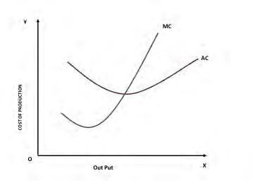

Fixed and Variable Cost :-
Fixed Cost: Fixed cost are those costs which do not vary with the volume of production. These costs remain fixed or constant up to a certain level of production. Even if the production is zero, a firm will have to incur fixed costs. Examples are rent, interest, depreciation, insurance, salaries etc. The fixed costs are also called supplementary costs, capacity costs or period costs or overhead costs.
Average fixed cost(fixed cost per unit) changes with a change in the quantity of production. If the volume of production increases, average fixed cost will decrease . If the quantity of production decreases, average fixed cost will increase. Thus, there Is an inverse relationship between fixed costs and quantity of production.
Short-run Cost Curve
Generally, in the short-run a firm will adjust output to demand by varying the variable factors. When the factors of production can be used in varying proportions, it means that the scale of operations of the firm can be changed. Each time the scale of operations is changed, a new short-run curve will have to be drawn for the firm such as SAC’ SAC” and SAC” in the next.
Short Run Cost Output Relationship

Fixed cost curve is a horizontal line which is parallel to the ‘X’ axis. This cost is constant with respect to output in the short run. Fixed cost does not change with output. It must be paid even if ‘0’ units of output are produced. For example: if you have purchased a building for the business you have invested capital on building even if there is no production
Total fixed cost (TFC) consists of various costs incurred on the building, machinery, land, etc.. For example if you have spent Rs. 2 Lakhs and bought machinery and building which is used to produce more than one batch of commodity, then the same cost of Rs. 2 Lakhs is fixed cost for all batches. The total variable costs vary according to the output. Whenever the output increases the firm has to buy more raw materials, use more electricity, labour and other sources therefore the TVC curve is upward sloping. The total cost consists of fixed (TFC) and variable costs (TVC). The TFC of Rs. 2 Lakhs is included with the variable cost throughout the production schedule so the total cost (TC) is above the TVC line.
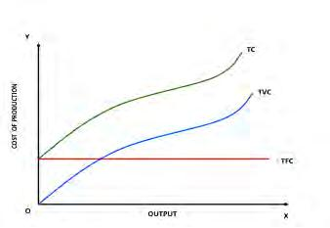
Graph – Total Cost Curves

Graph – Average Cost Curves

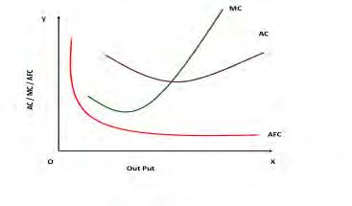

The above set of graphs indicates clearly that the average variable cost curve looks like a boat. Average fixed cost curve declines as output increases and it is a hyperbola to the origin. The Marginal cost curve slopes like a tick mark which declines up to an extent then it starts increasing along with the output. Pont at which marginal cost curve cuts the average variable cost is the minimum cost of production.
Average fixed cost is obtained by dividing total fixed cost by total output. Total fixed and and average cost curves and Schedules
Output | TC | TFC | TVC | AFC | ATC | AVC | MC
0 | v1200 | 300 | - | - | - | - | -
1 | 1800 | 300 | 1500 | 300 | 1800 | 1500 | 600
2 | 2000 | 300 | 1700 | 150 | 1000 | 850 | 200
3 | 2100 | 300 | 1800 | 100 | 700 | 600 | 100
4 | 2250 | 300 | 1950 | 75 | 562.5 | 487.5 | 150
5 | 2600 | 300 | 2300 | 60 | 520 | 460 | 350
6 | 3300 | 300 | 3000 | 50 | 550 | 500 | 700
Total Cost, Total Fixed Cost and Unit Costs

Graph - Average Cost Curves
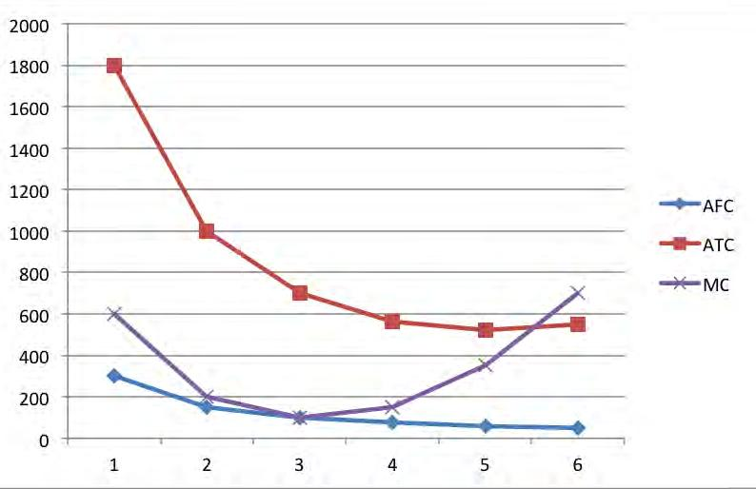

Optimum Output And Minimum Cost

The MC and AC curves are mirror image of the MP and AP curves. It is presented in the above graph.

All organizations aim for maximum output with minimum cost. To achieve this goal they like to derive the point where optimum output can be produced with the given amount of input factors and with a minimum average cost. In the graph the MP=AP at maximum average production. On the other hand MC = AC at minimum average variable cost. Therefore this is the optimum output to be produced to achieve their managerial goals.
Graph – Optimum Cost And Output

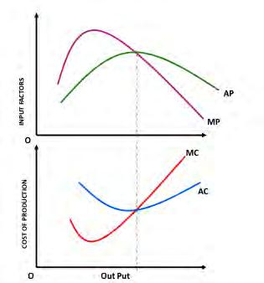

The above set of cost curves explain the cost output relationship in the short period but in the long run there is no fixed cost because all costs vary over a period of time. Therefore in the long run the firm will have only average cost curve that is called as long run average cost curve (LAC). Let us see how the average cost curve is derived in the long run. This LAC also slopes like the short period average cost curve (U shaped) provided the law of diminishing returns prevails. In case the returns to scale are increasing or constant then the LAC curve will have a different slope. It will be a horizontal line, which is parallel to the ‘X’ axis.
Cost Output Relationship In The Long Run

In the long run costs fall as output increases due to economies of scale, consequently the average cost AC of production falls. Some firms experience diseconomies of scale if the average cost begins to increase. This fall and rise derives a U shaped or boat shaped average cost curve in the long run which is denoted as LAC. The minimum point of the curve is said to be the optimum output in the long run. It is explained graphically in the chart given below.

Graph – Long Run Average Cost Curve

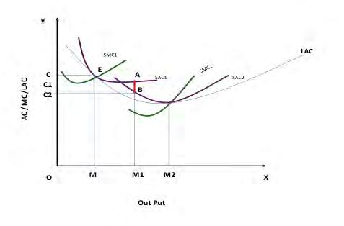

In the long run all factors are variable and the average cost may fall or increase to A, B respectively but all these costs are above the long run cost average cost. LAC is the lower envelope of all the short run average cost curves because it contains them all. At point ‘E’ the SAC1 and SMC1 intersects each other, in case the organization increases its output from OM to OM1 they have to spend OC1 amount. In case the organization purchases one more machine (increase in fixed cost) then they will get a new set of cost curves SAC2, and SMC2. But the new average cost curve reduces the cost of production from OC1 to OC2.That means they can save the difference of C1C2 which is nothing but AB. Therefore in the long run due to business expansion a firm can reduce their cost of production. During their business life they will meet many combinations of optimum production and minimum cost in different short periods. In the long run due to law of diminishing returns the long run average cost curve LAC also slopes like boat shape.

Cost Determinants

The cost of production of goods and services depends on various input factors used by the organization and it differs from firm to firm. The major cost determinants are:

1.Level of output: The cost of production varies according to the quantum of output. If the size of production is large then the cost of production will also be more.

2.Price of input factors: A rise in the cost of input factors will increase the total cost of production.

3.Productivities of factors of production: When the productivity of the input factors is high then the cost of production will fall.

4.Size of plant: The cost of production will be low in large plants due to mass production with mechanization.

5.Output stability: The overall cost of production is low when the output is stable over a period of time
6.Lot size: Larger the size of production per batch then the cost of production will come down because the organizations enjoy economies of scale.

7.Laws of returns: The cost of production will increase if the law of diminishing returns appliesin the firm.

8.Levels of capacity utilization: Higher the capacity utilization, lower the cost of production

9.Time period: In the long run cost of production will be stable.

10.Technology: When the organization follows advanced technology in their process then the cost of production will be low.

11.Experience: over a period of time the experience in production process will help the firm to reduce cost of production.

12.Process of range of products: Higher the range of products produced, lower the cost of production.

13.Supply chain and logistics: Better the logistics and supply chain, lower the cost of production.

14.Government incentives: If the government provides incentives on input factors then the cost of production will be low

Short run cost: Cost over a period during which some factors of production are fixed.
• Long run cost: Cost over a long period to permit changes in all factors of production.
• Post costs: Actual costs incurred in the past.
• Future costs: Which are to be incurred in near future.
• Prime costs: Refers to variable or direct costs.
• Incremental cost: Added cost of a change in the level of production.
• Sunk cost: Which have all ready been incurred and cannot be altered.
• Traceable cost: Which are easily be identified by a producing unit.
• Non Traceable cost: Which are not traceable to plant, department of unit of operation.
• Explicit cost & inexplicit cost: Total cost of production of a commodity can be said to include
expenditure explicit cost and non expenditure or inexplicit cost.
• Controllable cost: That can be controlled by some executive action in the part of management.
• Non Controllable cost: That can not be controlled through any administrative or supervisory
action.
• Total Cost: Made up of both fixed and variable cost.
• Average Cost: Product of total cost to units of output or sum of average variable cost and fixed
cost.

- Define sunk Cost ?

- Distinguish between Accounting cost and economic cost?

- Define fixed cost ?

- What is explicit Cost ?

- What are Social costs ?

- What is Marginal revenue

- Distinguish between marginal cost and incremental cost ?

- Distinguish between long run cost and short run cost ?

- State the relation ship between TC, AC and MC ?

- Distinguish between marginal revenue and incremental revenue ?

